Please see back side 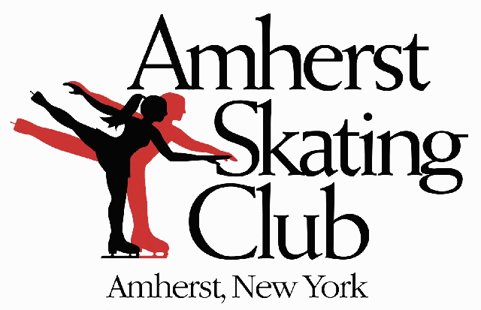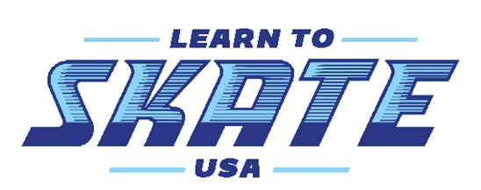
For information Summer 2021 Learn to Skate
Northtown Center, Amherst, NY
6 Week Session ~ July 8th - August 19th
Fee $78.00
Deadline: June 30th
Each class is a 25 minute lesson & 25 min. supervised practice ice. All classes available for ages 3 and up. Helmets recommended. Please complete a separate form for each skater. Skate rental needed: yes ___ no___ size___ figure____ hockey____ (whole sizes only) $5 each time
Skater’s Last Name: _______________________ First Name: __________________________ M F
Address: _________________________________ City__________________ Zip ________________ Phone: _________________ Email: _______________________________Birth Date:____________

Day | Dates | Time | Levels Offered
Monday | 7/12 - 8/16 | 6:30 - 7:20 | Snowplow Sam, Basic 1 - 6, Freestyle Class & Adults
Tuesday | 7/13 - 8/17 | 6:30 - 7:20 | Hockey 1 - 4 & Power Skating
Thursday | 7/8 - 8/19 | 6:30 - 7:20 | Snowplow Sam, Basic 1 - 6 & Freestyle Class
* Must have passed Basic 6 for Freestyle class. No equipment needed for Hockey class. Snowplow Sam is for 3 & 4yr olds.
*Must have passed Hockey level 4 for power skating
**All participants in our program must be current Learn to Skate USA members before we can process your application. This includes a welcome packet with their member card & number, skater record book, parent handbook, Learn to skate USA magazine and sports accident insurance. Please go to the following website to become a member. www.learntoskateusa.com
LEARN TO SKATE USA MEMBERSHIP #_________________________________________________________________________
PLEASE SIGN THIS SKATER UP FOR DAY ______________________TIME ______________________LEVEL___________________
____________________________________________________ __________________________________________________
Please print name of parent/guardian or adult skater Signature of parent/guardian or adult skater

Emergency contact name and phone#__________________________________________________________________________
The Amherst Skating Club, its officers and representative shall not be responsible for damages or injuries suffered by skaters, officials or spectators. By signing this application, you waive any right to a claim against the Amherst Skating club, its members or officers, for any injuries you may sustain. I give permission for my skater to be in any on ice photos that may be used for promotional purposes; YES NO
For additional information go to www.amherstskatingclub.org or call (716) 634-3886 or email LTSdirector@amherstskatingclub.org
Please make checks payable to: Amherst Skating Club, mail to ASC, 1615 Amherst Manor Dr., Williamsville, NY 14221. ATTN: LTS or drop form and payment into ASC mailbox bottom floor Northtown Center. Another option is to pay and complete your application online and email to LTSdirector@amherstskatingclub.org

Office use only: Rec’d by: ___________ Amount Rec’d: _____________________ Date: ______________ online or Cash or Check#
Registering for Learn to Skate USA membership
If you had a membership in the past and are renewing:
1. Go to https://www.learntoskateusa.com
2. Click on “log in” and enter your membership ID, if you do not know your membership number please email; memberservices@learntoskateusa.com with your student name and date of birth and let them know you need the member number.
3. Enter your password, if you do not remember it or never created one, click on “forgot password” and a temporary one will be emailed to you.
4. Click on the renew button at the top of the screen and follow the prompts. Be sure to pick Amherst skating club program when that option is available.
If you are registering for skating classes for the first time:
1. Go to https://www.learntoskateusa.com
2. Click on “sign up” and follow the prompts. Be sure to pick the Amherst skating club program when that option is available.

